LAPLAND

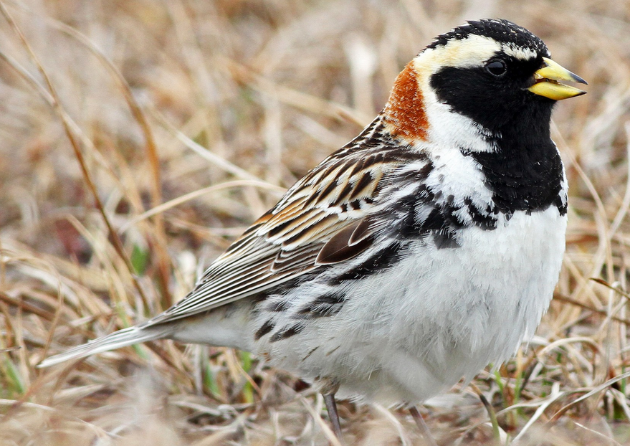 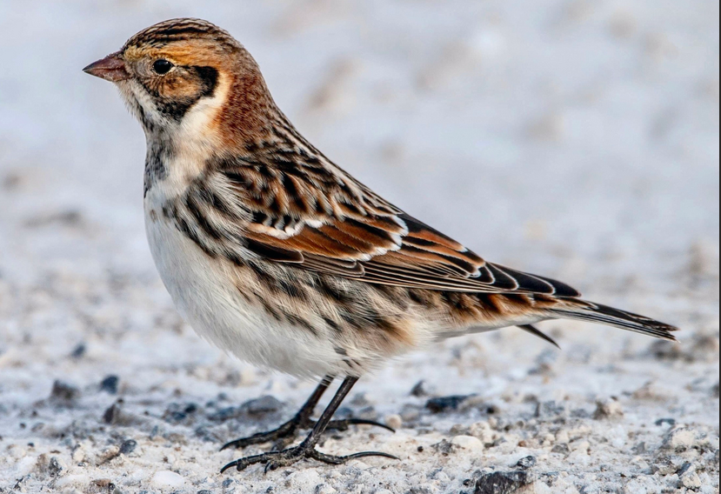



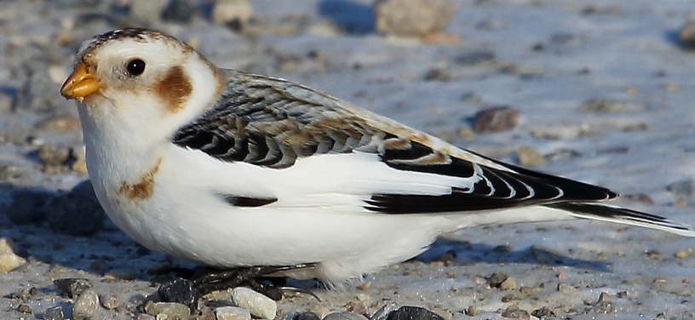

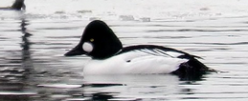

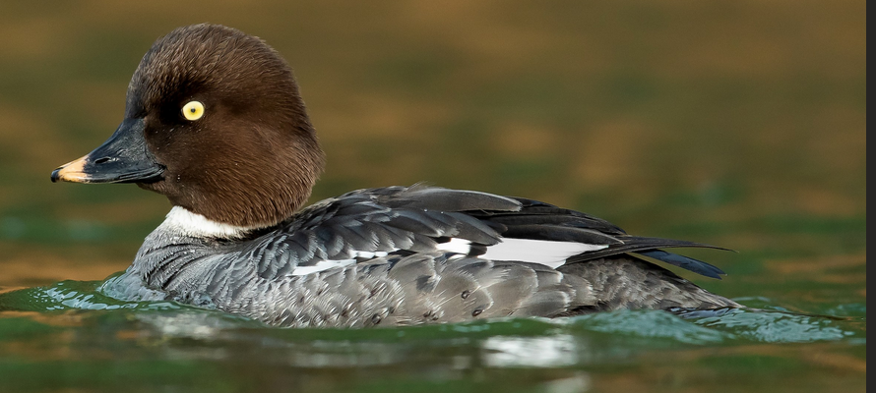

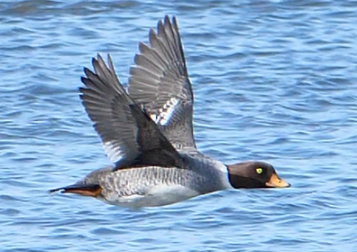

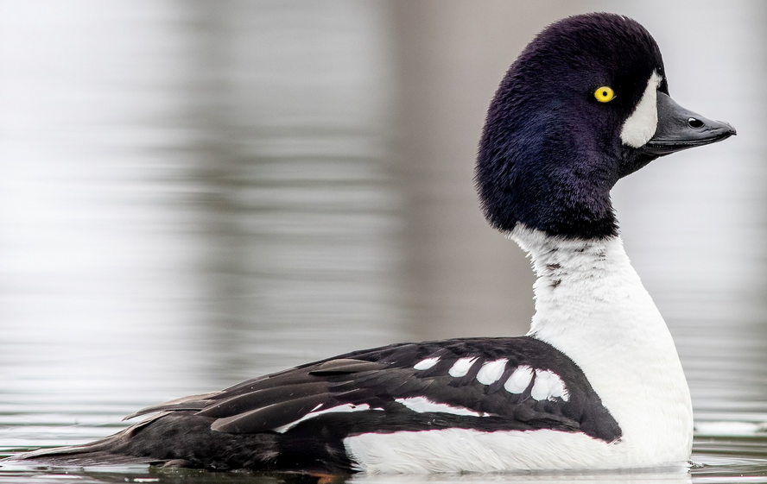

## **Royal Tern**

*loud, throaty, rolling kerrra*

## **Caspian**

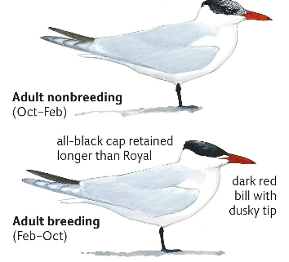

Larger; thicker bill; mottled cap.  
*deep, harsh, heron-like scream.*

## **Forster’s Tern**

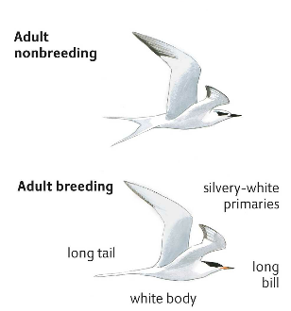

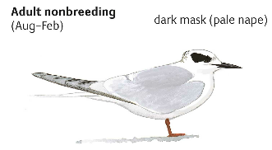

## **Sandwich Tern**

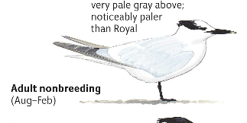

## **Mottled Duck**

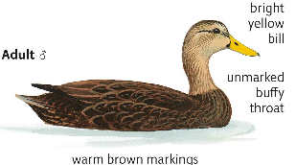  
 *(mallards have white stripe speculum)*

## **Fulvous Whistling Duck**

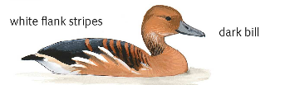

## **Black-bellied Whistling Duck**

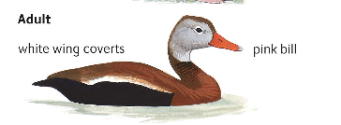

## **Little Blue Heron**

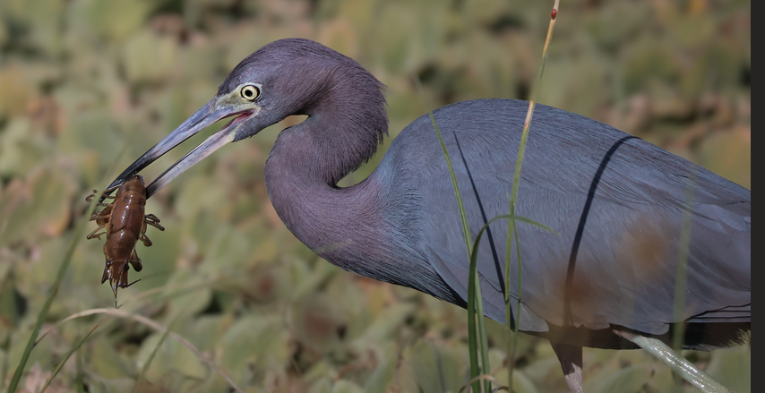**Green legs**

## **Tri-colored Heron**

**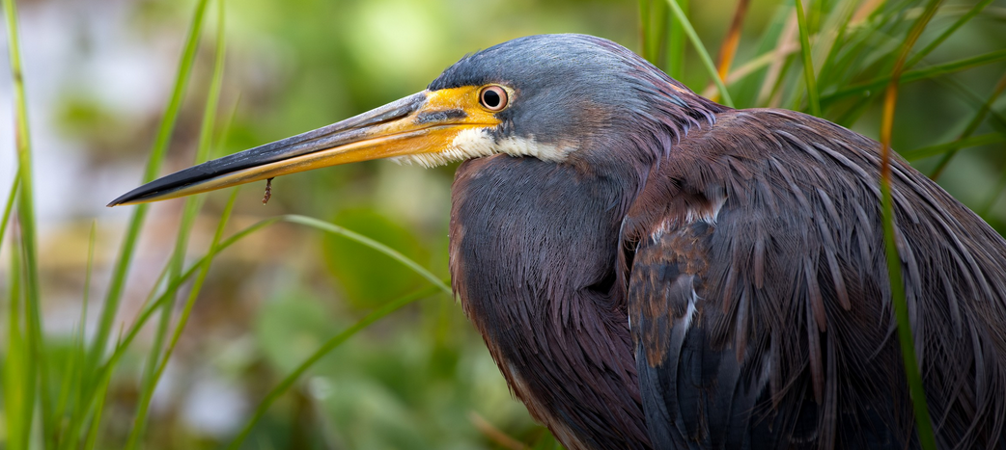  
Small, white belly & underwings**

## **Cattle Egret**

## 

## **Glossy Ibis**

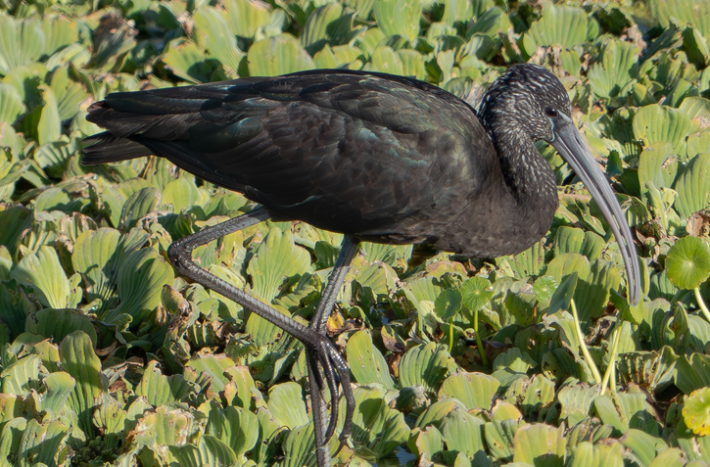

## **Anhinga**

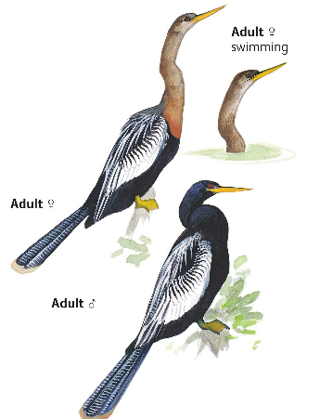

## **Caracara**

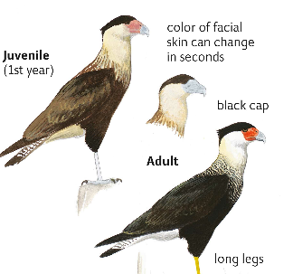

## **American Kestrel**

## **Short-tailed & Sharp-shinned**

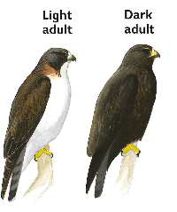 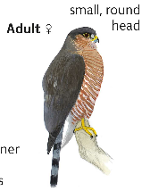

## **Bobwhite**

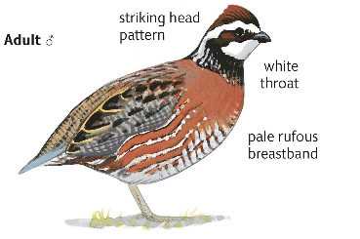

## **Limpkin**

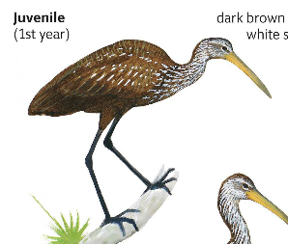

## **Purple Gallinule**

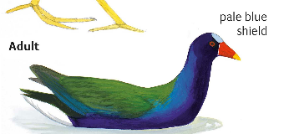

## **Swamphen**

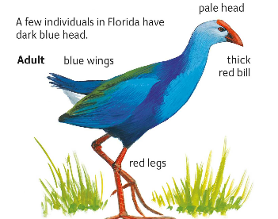

## **King Rail**

## **Virginia Rail**

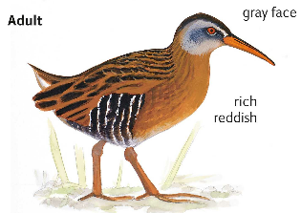

## **Wilson’s Snipe**

## **Least Bittern**

## **American Bittern**

## **Ring Neck Ducks**

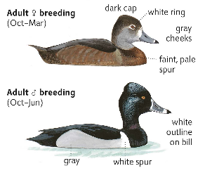

Bump on head  
 White spur (the ring on the neck)

## **Bufflehead**

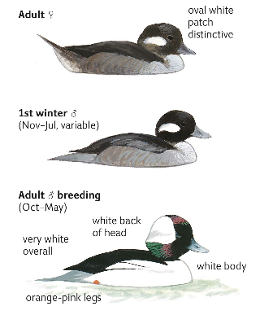

## **Scaups**

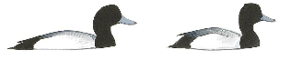

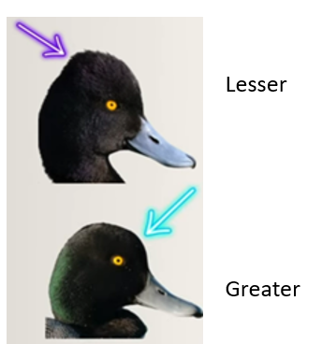

Greater

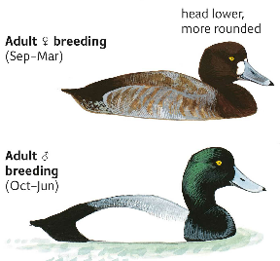

Lesser

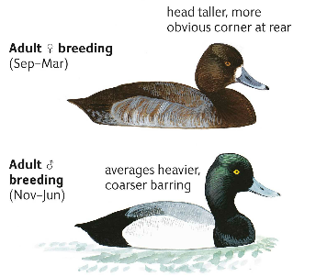

## **Ruddy Ducks**

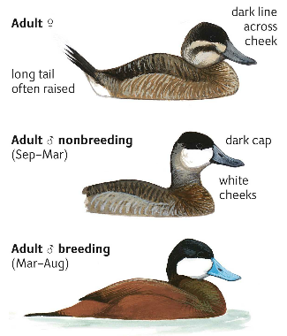

## **Northern Pintails**

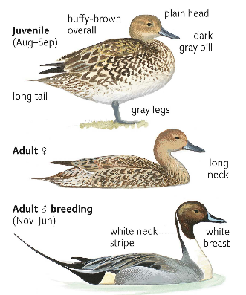

## **Female Ducks**

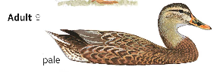

**MALLARD**  Bill Orange/Olive w/black spot   
 eye line, orange legs

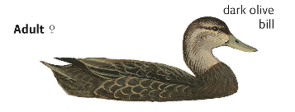**BLACK** Darker,Bill Olive Bill, eye line,   
 dark tail

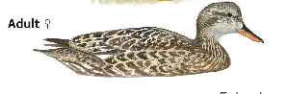**GADWALL** Square head, Bill Darker,   
 White patch

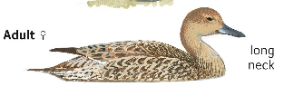  
**PINTAIL** Bill Gray; Plain face

## **Blue-winged Teal**

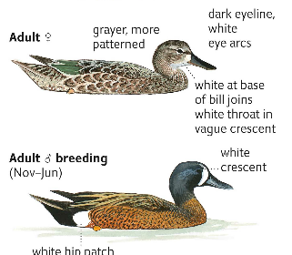

*Female has pale crescent at base of bill  
 Female has dark bill*

## **Green-winged Teal**

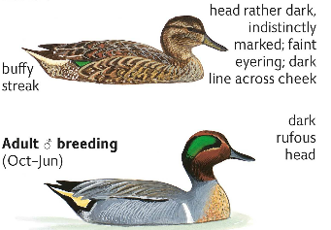

## **American Wigeon**

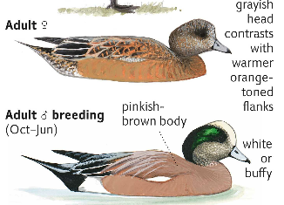

## **Eurasian Wigeon**

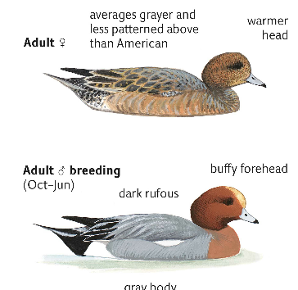

## **Mergansers**

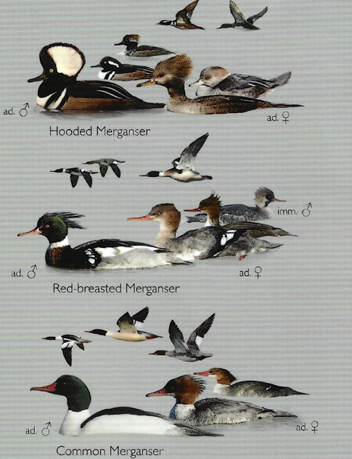

## **Goldeneyes**

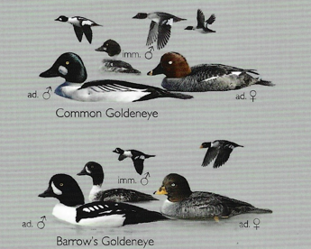

## **Other Ducks w/ White Spots**

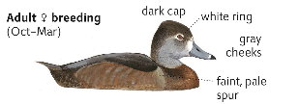  
 Female Ring-necked

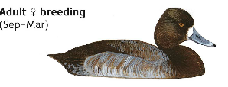  
Female Scaups

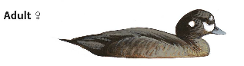

Female Harlequins

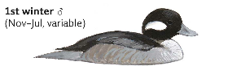

Female Buffleheads

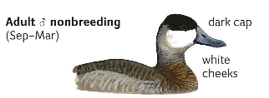

Ruddy Ducks

## **Redheads**

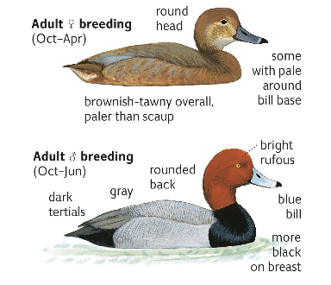

## **Canvasbacks**

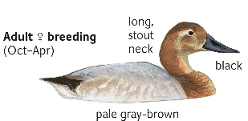

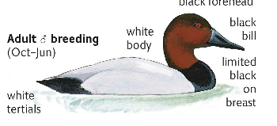

Black Bill

**Eurasian Wigeons & Green-winged Teal also have red heads!**

## **Glaucus Gulls**

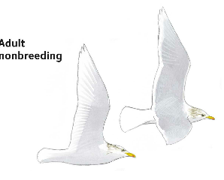

Large, white wingtips   
Massive bill (compared to Iceland)

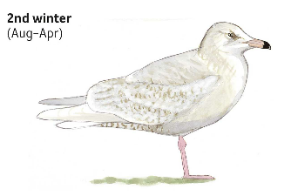

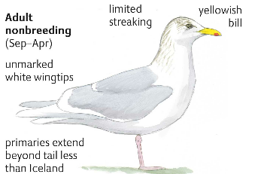

## **Iceland Gulls**

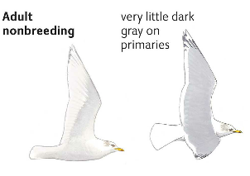

Rounder head

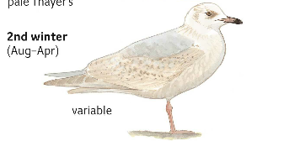

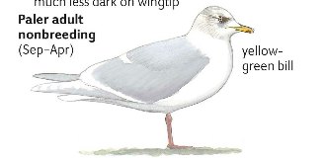

## **Herring Gulls**

Larger, Bigger Bill, Pink Legs

